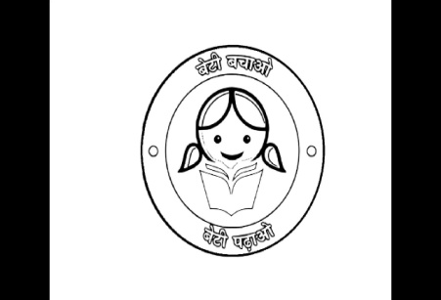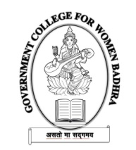

GOvt. COLLEGE FOR WOMEN, badhra

(Affiliated to Ch. Bansi Lal University, Bhiwani, AISHE Code: C-51945)

**Address: Dhigawa Road, Badhra, Ch. Dadri, Haryana, PIN: 127308**

*Tel.: 01252-253036, E-Mail: gcwbadhra@gmail.com, Website: http://www.gcwbadhra.ac.in*

|  |  |  |  |  |  |
| --- | --- | --- | --- | --- | --- |
| **Sr No.** | **Department** | **Programme Name** | **Programme Type** | **Total Seats** | **Sports Seats** |
| 1 | Arts | Bachelor of Arts | Govt | 320 | 0 |
| 2 | Commerce | Bachelor of Commerce | Govt | 80 | 0 |
| 3 | Science | Bachelor of Science in Physical Sciences | Govt | 100 | 0 |
| 4 | Arts | Master of Arts - History | Govt | 40 | 0 |
| 5 | Arts | Master of Arts - Political Science | Govt | 40 | 0 |
| 6 | Science | Master of Science - Geography | Govt | 80 | 0 |